Front End Engineering-II

Project Report Semester-III (Batch-2023)



**Supervised By: Submitted By:**

Amitabh Srivastava Gouri Sharma,2310990423 (G5)

Dhruv Sharma,2310990410(G5)

Aryan Singla,2310990389 (G5)

Aryan Garg,2310990387(G5)

Department of Computer Science and Engineering Chitkara University Institute of Engineering & Technology,

Chitkara University, Punjab

**Abstract**

**Overview:**

An interactive restaurant website ‘Bite&Dine’, combines responsive design, dynamic menus, and secure online ordering. Built using HTML, CSS, and JavaScript, it prioritizes user experience through intuitive navigation and visually appealing elements. Development involves wireframing, design, coding, testing, and deployment.

**Features:**

* User-Friendly Interface:  
  The platform is designed for ease of use, allowing users to navigate menus, place orders, and discover new dining options effortlessly. The clean and intuitive design makes the entire process seamless and enjoyable.
* Personalized Recommendations:  
  Bite&Dine’s smart recommendation engine suggests dishes and restaurants based on users' past orders and ratings, making each dining experience uniquely tailored to individual preferences.
* Exclusive Deals and Offers:  
  Bite&Dine offers exclusive discounts, loyalty rewards, and special deals that are only available to its users, providing great value with every order.
* Product Reviews and Ratings: Customers can leave reviews and ratings to help others make informed purchasing decisions.
* 24/7 Customer Support:  
  A dedicated customer support team is available around the clock to assist users with any queries, ensuring a smooth and hassle-free experience**.**

**Technical Details:**

The project “RESTAURANT WEBPAGE” is made by using HTML, CSS, JAVAScript.

* HTML: It is used to create basic structure i.e. webpage development of the project which uses various types of tags such as ‘anchor tags(<a>,</a>)’, ‘paragraph tags(<p>,</p>) etc.
* CSS: It is used to decorate and add various styles

for development of webpage. In our project we had also used CSS tools such as padding, borders, colors etc. to make our project attractive.

* JAVAScript: It is used to create a interface and dynamic webpage to interact with the users and to execute complex operations. We had used various terms like ‘script tags’, ‘calling element by it’s id’, ‘concept of variables’ etc.

**Goals and Objectives:**

• **Attract new customers:** Showcase the restaurant's offerings and create a positive online presence.

• **Retain existing customers:** Provide convenience and personalized experiences through online ordering and reservations.

• **Increase revenue:** Drive sales through efficient online ordering and promotions.

• **Build brand awareness:** Establish the restaurant's identity and reputation.

• **Improve customer satisfaction:** Offer a seamless and enjoyable online experience.

• **Gather customer data:** Collect valuable information for marketing and analytics.

• **Enhance operational efficiency:** Streamline processes like order taking and reservations.

• **Stay competitive:** Keep up with industry trends and technological advancements.

**Target Audience:**

• Local residents: People living in the vicinity of the restaurant.

• Tourists and visitors: People traveling to the area.

• Business professionals: Individuals who need convenient dining options for meetings or lunches.

• Families: Groups seeking a casual and enjoyable dining experience.

• Foodies and food enthusiasts: People interested in exploring new cuisines and culinary experiences.

• Social groups: Friends and colleagues looking for a place to gather and socialize.

• Online food delivery users: Individuals who frequently order food online.

**Conclusion:** Bite&Dine offers a platform that not only simplifies the online food ordering process but also enhances it. We understand that every customer is unique, and so are their dining preferences. Bite&Dine bridges the gap between quality dining and online convenience, offering a curated selection of top-tier restaurants, personalized recommendations, and a user-friendly experience that makes ordering food a pleasure, not a chore..

**Table of Content**

|  |  |  |
| --- | --- | --- |
| S.No. | Name | Page No. |
| 1. | Introduction | 6-7 |
| 2. | Problem Definition And Requirements | 8-10 |
| 3. | Proposed Design / Methodology | 11-13 |
| 4. | Results | 14-21 |

1. **INTRODUCTION**
   1. **Background**

In today's digital age, a strong online presence is essential for businesses to thrive. For restaurants, a well-designed and interactive website can significantly impact customer acquisition and retention. This project aims to create a comprehensive restaurant website that not only showcases the establishment's offerings but also provides a seamless user experience.

The website will serve as a digital storefront, allowing customers to explore the menu, make online reservations, and place orders. By incorporating interactive features and a responsive design, the website will cater to a diverse range of users, from local residents to tourists and business professionals.

**1.2 Objectives**

• **Attract new customers:** Showcase the restaurant's offerings and create a positive online presence.

• **Retain existing customers:** Provide convenience and personalized experiences through online ordering and reservations.

• **Increase revenue:** Drive sales through efficient online ordering and promotions.

• **Build brand awareness:** Establish the restaurant's identity and reputation.

• **Improve customer satisfaction:** Offer a seamless and enjoyable online experience.

• **Gather customer data:** Collect valuable information for marketing and analytics.

• **Enhance operational efficiency:** Streamline processes like order taking and reservations.

• **Stay competitive:** Keep up with industry trends and technological advancements.

**1.3 Significance**

An interactive restaurant website offers several significant benefits:

* **Enhanced Customer Experience:** A well-designed website provides a seamless and enjoyable user experience, encouraging customers to return.
* **Increased Revenue:** Online ordering and reservations can drive sales and increase revenue.
* **Improved Brand Reputation:** A positive online presence can enhance the restaurant's reputation and credibility.
* **Data-Driven Insights:** Website analytics can provide valuable insights into customer behavior, preferences, and trends.
* **Competitive Advantage:** A modern and interactive website can differentiate the restaurant from competitors.
* **Accessibility:** A responsive website ensures accessibility on various devices, reaching a wider audience.
* **Operational Efficiency:** Online tools can streamline processes like order taking and reservations, improving efficiency.
* **Marketing Platform:** The website can serve as a platform for promotions, events, and community engagement.

In essence, an interactive restaurant website is a powerful tool for attracting customers, building brand loyalty, and driving business growth.

**1.4 Conclusion**

In today's digital landscape, an interactive restaurant website is essential for attracting customers, building brand awareness, and driving business growth. By offering a seamless user experience, providing convenient features like online ordering and reservations, and collecting valuable data, such a website can significantly enhance a restaurant's success.

Through careful planning, design, and development, a restaurant can create a compelling online presence that not only attracts new customers but also fosters loyalty among existing patrons.

1. **Problem Definition and Requirements**

**2.1 Problem Statement**

In today's fast-paced world, dining preferences have evolved significantly. Consumers seek the convenience of ordering food online without compromising on quality, variety, or the dining experience . However, online food platforms often fail to provide a seamless, personalized, and customer-centric service. Users frequently encounter issues such as

* limited options
* cumbersome interfaces
* generic recommendations
* ack of transparency in delivery
* minimal customer support.

By focusing on customer satisfaction, providing user-friendly interface, and delivering exclusive deals, Bite&Dine ensures that users can enjoy their favorite meals effortlessly and confidently. Bite&Dine is the solution for those who demand more from their online dining experience—a platform where convenience meets culinary excellence.

**Key challenges include:**

* **Technical Complexity:** Developing a website that is responsive, user-friendly, and compatible with different devices can be technically challenging.
* **User Experience Design**: Creating a visually appealing and intuitive website that meets the needs of diverse users can be a challenge.
* **Content Creation:** Developing high-quality content, including images and descriptions of menu items, can be time-consuming.
* **Ensuring Responsive Design**: Making sure the web page is fully responsive, adapting smoothly to different screen sizes and orientations.

**2.2 Software Requirements**

To successfully complete this project, the following software requirements are necessary:

1. **HTML (HyperText Markup Language)**: The fundamental technology for structuring the web content. HTML is used to define the layout of the profile page, including the placement of images, text, and forms.
2. **CSS (Cascading Style Sheets)**: CSS is essential for styling the web page. It is used to control the visual presentation of the HTML elements, ensuring that the page mimics the aesthetic qualities of Instagram. CSS also plays a critical role in implementing responsive design, ensuring the page looks good on all devices.
3. **JavaScript**: JavaScript is used to enhance the interactivity of the web page. It handles user actions, such as form submissions and dynamic content loading. JavaScript also plays a role in validating user inputs and enhancing the overall user experience with smooth transitions and effects.
4. **Text Editor/IDE**: A text editor or integrated development environment (IDE) like Visual Studio Code, Sublime Text, or Atom is necessary for writing and managing the code.
5. **Web Browser**: A modern web browser such as Google Chrome, Mozilla Firefox, or Microsoft Edge is required to test and debug the web application.
6. **Version Control System (Optional)**: Git or any version control system can be used to manage code versions, especially when collaborating with others or keeping track of changes over time.

**2.3 Hardware Requirements**

The hardware requirements for developing and running this project are minimal, given the nature of the technologies involved:

* + 1. **Development Machine**:
* **Processor**: Any modern processor with at least 1 GHz clock speed (Intel, AMD, or ARM-based CPUs).
* **RAM**: Minimum 4 GB RAM, though 8 GB or more is recommended for smoother multitasking and running the IDE alongside a web browser.
* **Storage**: At least 100 MB of free disk space for project files, text editor, and browser.
* **Operating System**: Compatible with Windows, macOS, or Linux.
  + 1. **Display**: A monitor with a minimum resolution of 1280x720 pixels is required. A higher resolution is recommended for more comfortable UI design and testing of responsive layouts.
    2. **Internet Connection**: While an internet connection is not strictly necessary for development, it is required for accessing external resources like documentation, tutorials, and third-party libraries (e.g., Google Fonts or external CSS frameworks).

**2.4 Data Sets**

In this project, data sets refer to the user data (e.g., usernames, contact information) that the application needs to manage. Although a database isn't implemented in this project yet, placeholders for user data can be simulated:

* + - **User Credentials**: Test data including sample usernames and order information for the form functionality. This can be hardcoded into JavaScript for demonstration purposes.
    - **Images**: External resources, such as images, which are essential for creating a realistic page experience. These should be carefully selected to represent the typical content found on restaurant webpage.

1. Proposed Design / Methodology

3.1 Introduction

The objective of this project is to create a replica of an Instagram profile page using HTML, CSS, and Bootstrap. The design aims to emulate the look and feel of the Instagram interface, including the profile section, stories, posts, and bottom navigation bar. This document provides a detailed overview of the proposed design, file structure, and the algorithms used in the project.

**3.2 File Structure**

The project’s file structure is organized as follows:

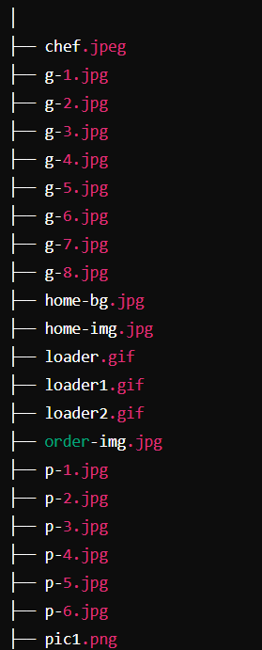 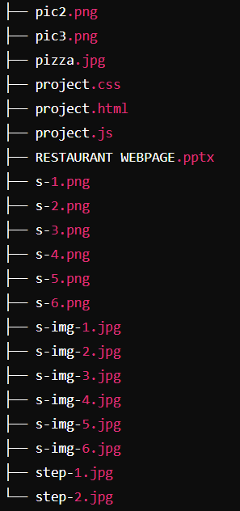

Fig 3.2.1 Fig – 3.2.2

**3.3 Methodology**

**3.3.1 HTML Structure**

The HTML structure is designed to divide the profile page into distinct sections using semantic HTML5 elements. The key components of the structure include:

* **Container**: A div with the class container wraps all the content and centers it on the page.
* **Top Bar**: The top navigation bar (top-bar) contains buttons for navigation and a title bar with the Instagram logo and verified badge.
* **Bottom Bar**: The bottom navigation bar (bottom-bar) provides quick access to different parts of the application.

**3.3.2 CSS Styling**

Custom CSS is used to style the elements to closely match Instagram's design aesthetics:

* **Typography**: The custom font is imported and applied to all text elements for a clean and modern look.
* **Layouts**: Flexbox and Grid are heavily used to ensure the layout is responsive and elements are aligned properly.
* **Colors and Borders**: The color scheme uses subtle grays for borders and active elements.
* **Responsive Design**: The layout adapts to different screen sizes by using flexible units and media queries, ensuring that the page looks good on both mobile and desktop devices.

**3.3.3 Algorithms Used**

* **Responsive Grid Layout**: The grid layout for the uploaded photos is achieved using CSS Grid, which allows for a flexible number of columns depending on the screen size. This ensures that the images are always aligned properly, regardless of the viewport width.
* **Horizontal Scrolling for Stories**: The stories section is designed using a horizontal scroll view.
* **Active Tab Indication**: The active tab is highlighted by changing the border color and applying a bottom border to the active tab button.

1. Results

Here are some screenshots of the working project along with the code:

4.1 Loading:

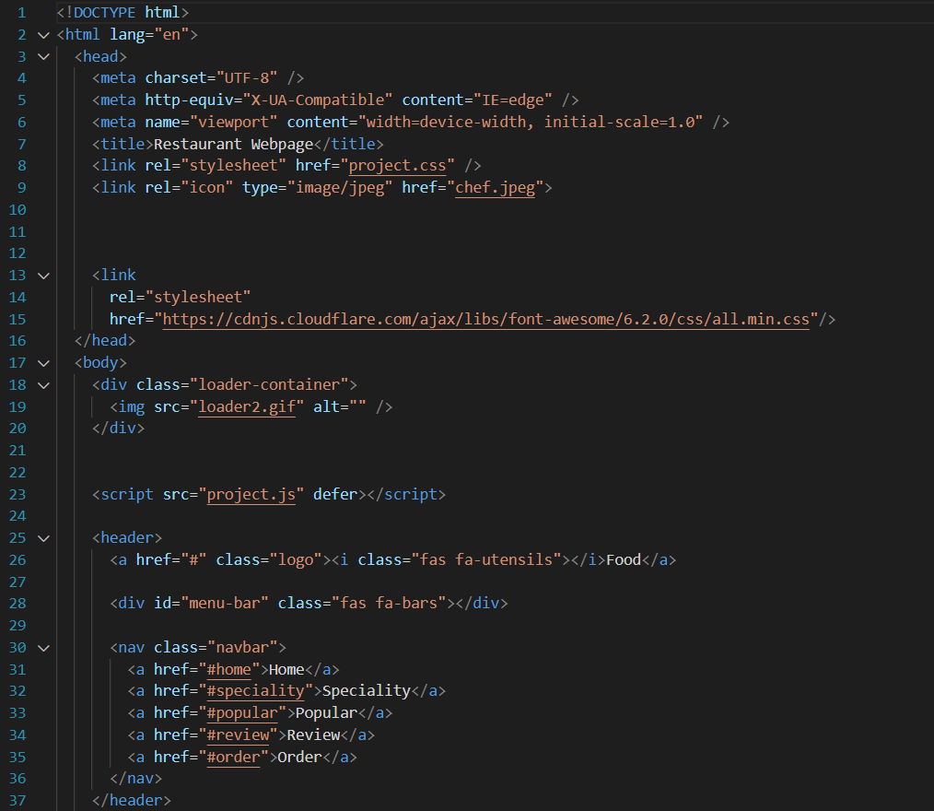

Fig. 4.1.1

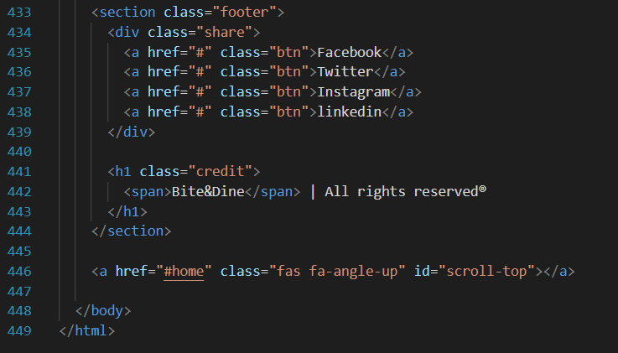

Fig. 4.1.2

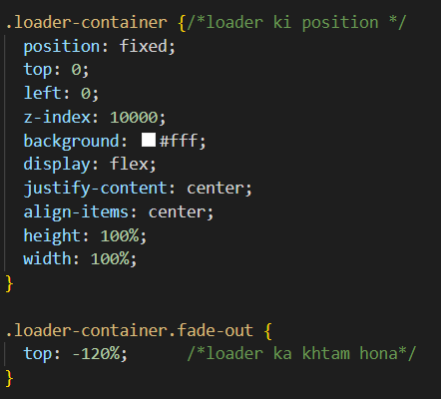

**Fig 4.1.3**



**Fig 4.1.4**

4.2 Log In Page

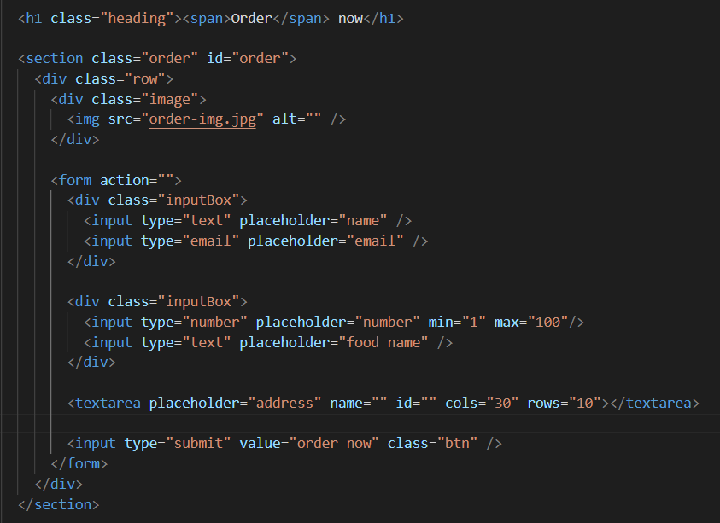

Fig 4.2.1

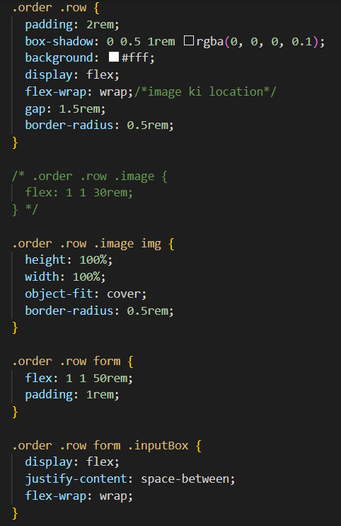

Fig 4.2.2

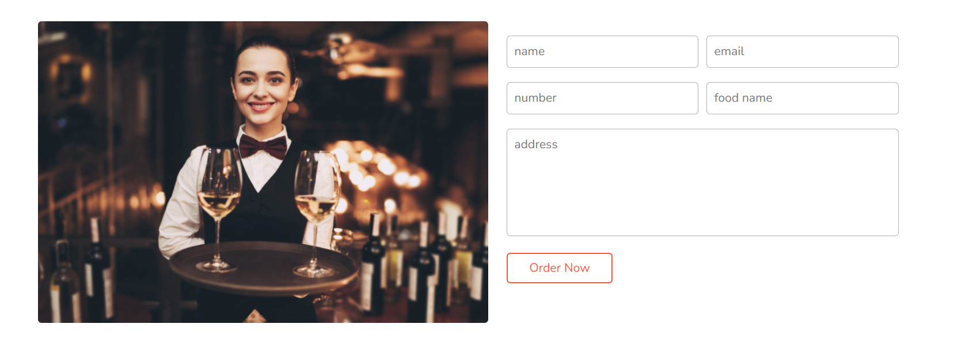

Fig 4.2.3

* 1. Home Page

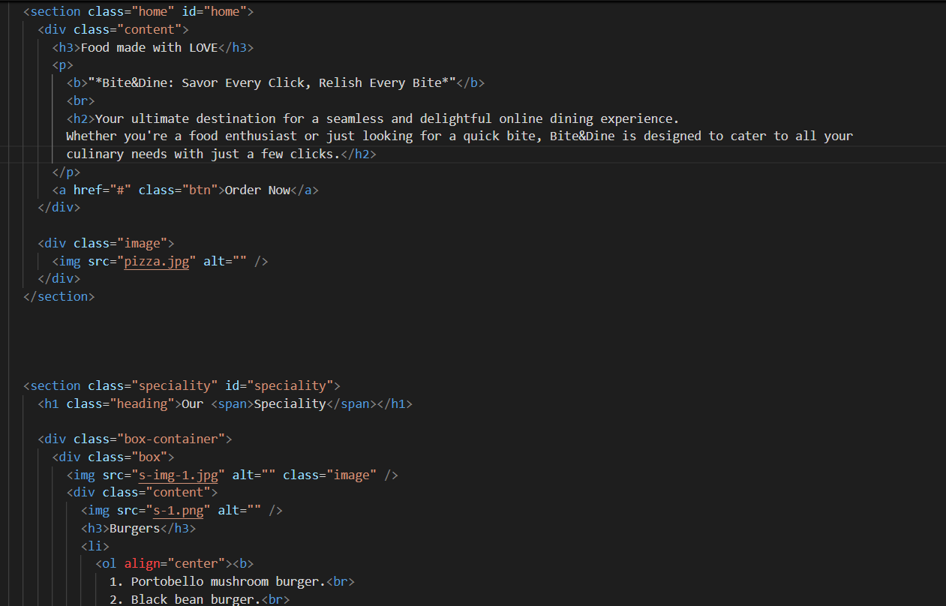

Fig 4.3.1

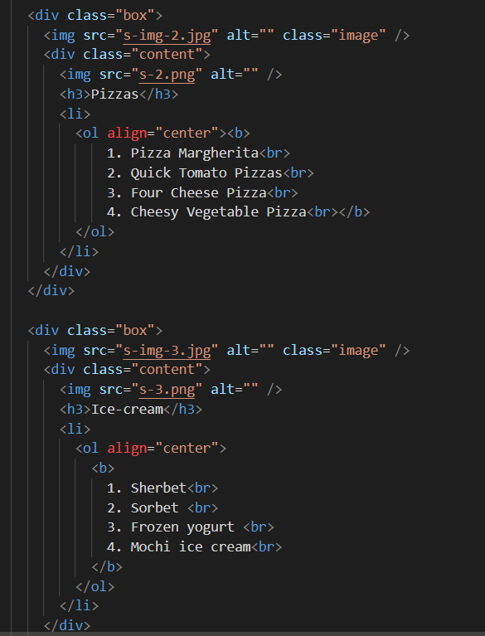

Fig 4.3.2

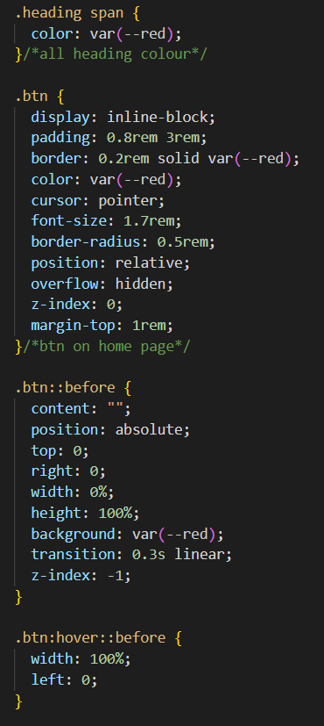 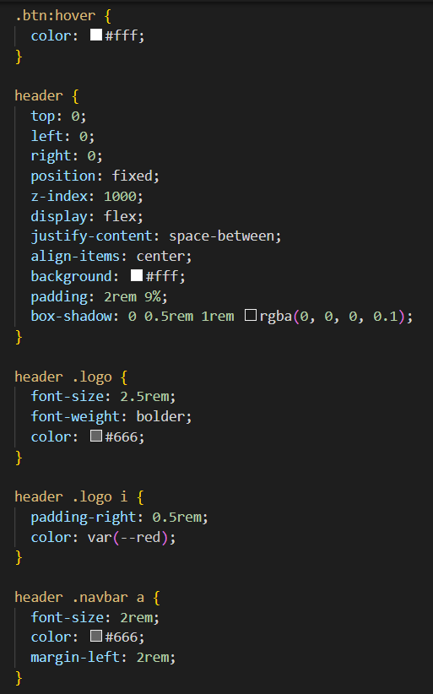

Fig – 4.3.3 Fig – 4.3.4

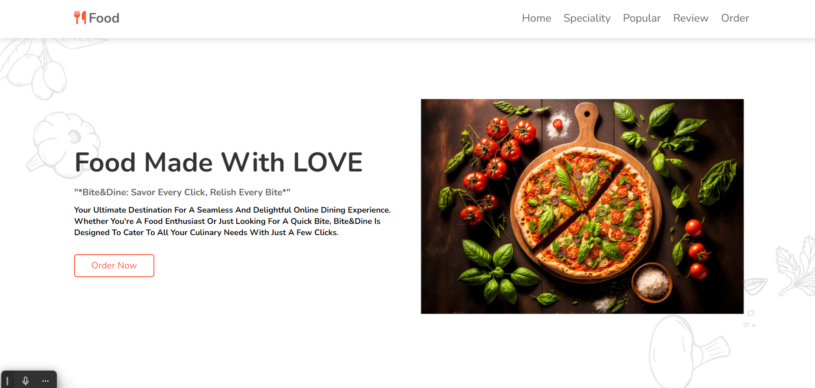

Fig – 4.3.5